Create a git repository in local
- Open the GIT Bash and move to the local folder
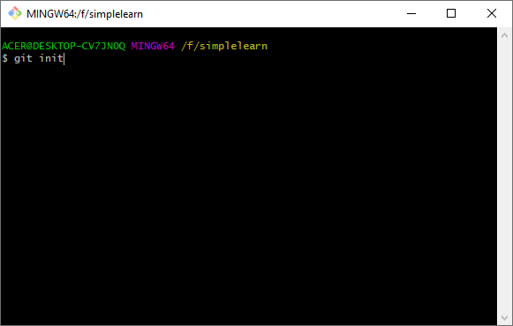
- Configure the github to the local folder
git remote add origin https://github.com/chockkalingamk/Simplilearn.git
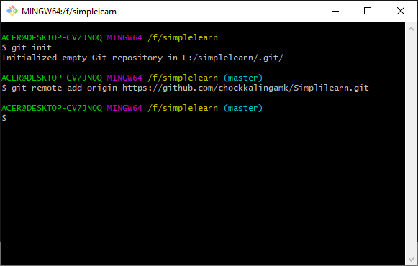

- Pull the source code folder from the GIT hub to local
git pull origin master
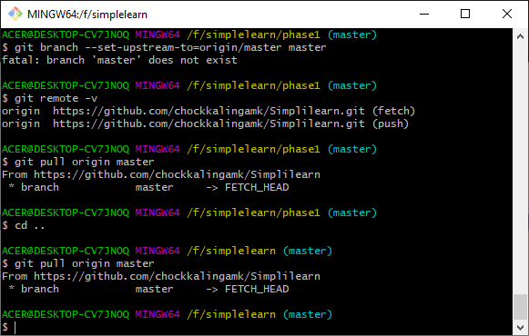
Import the source code into the eclipse

- Import a new java project
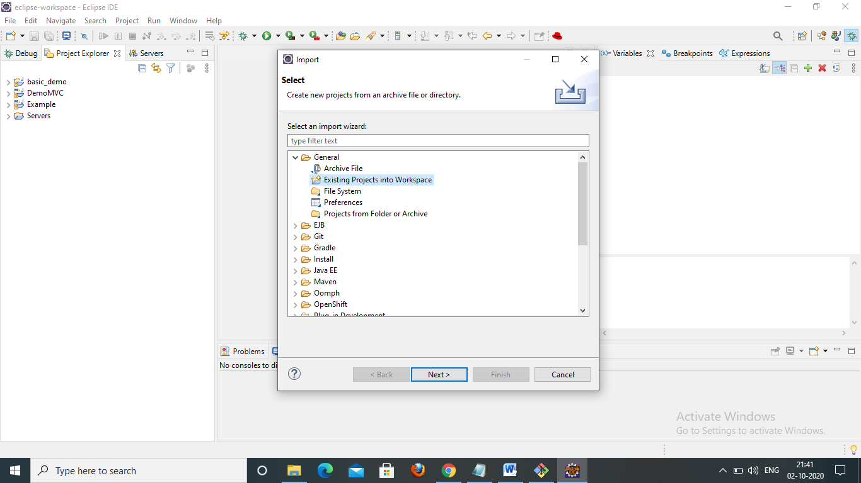
- Browse the directory from GIT
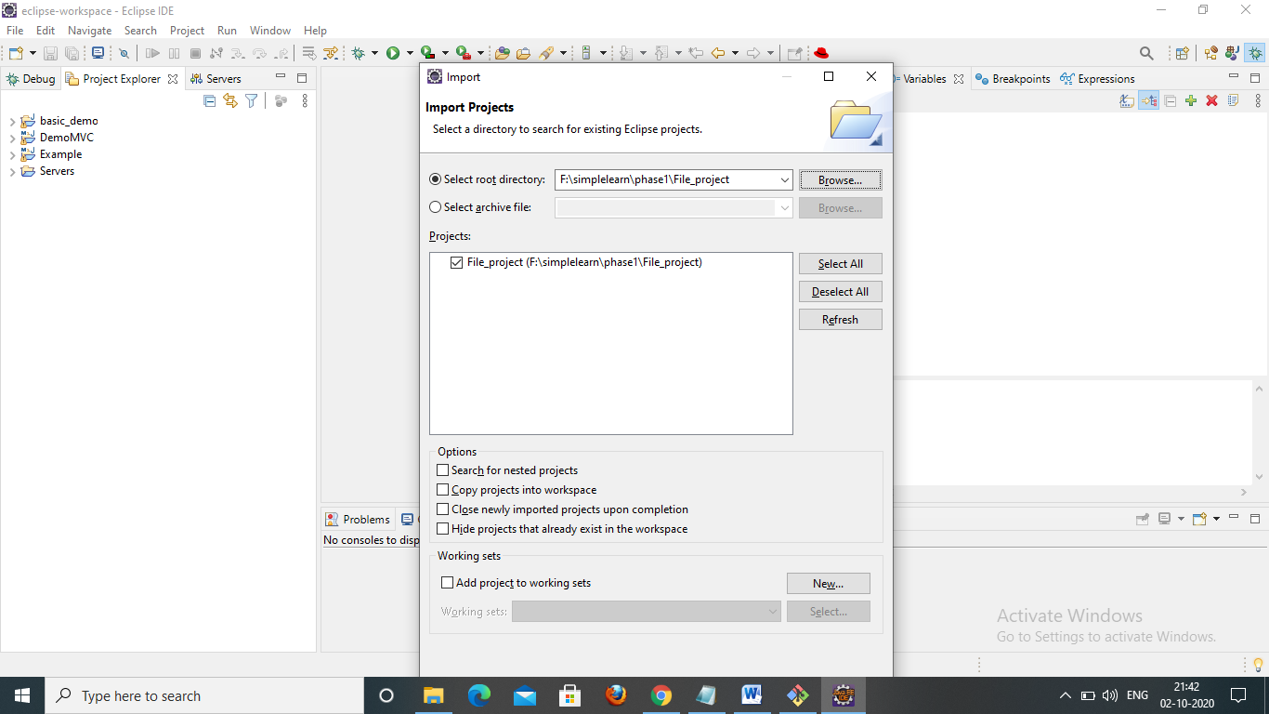
- Click Finish
- Open Application.java from the source folder of File_project
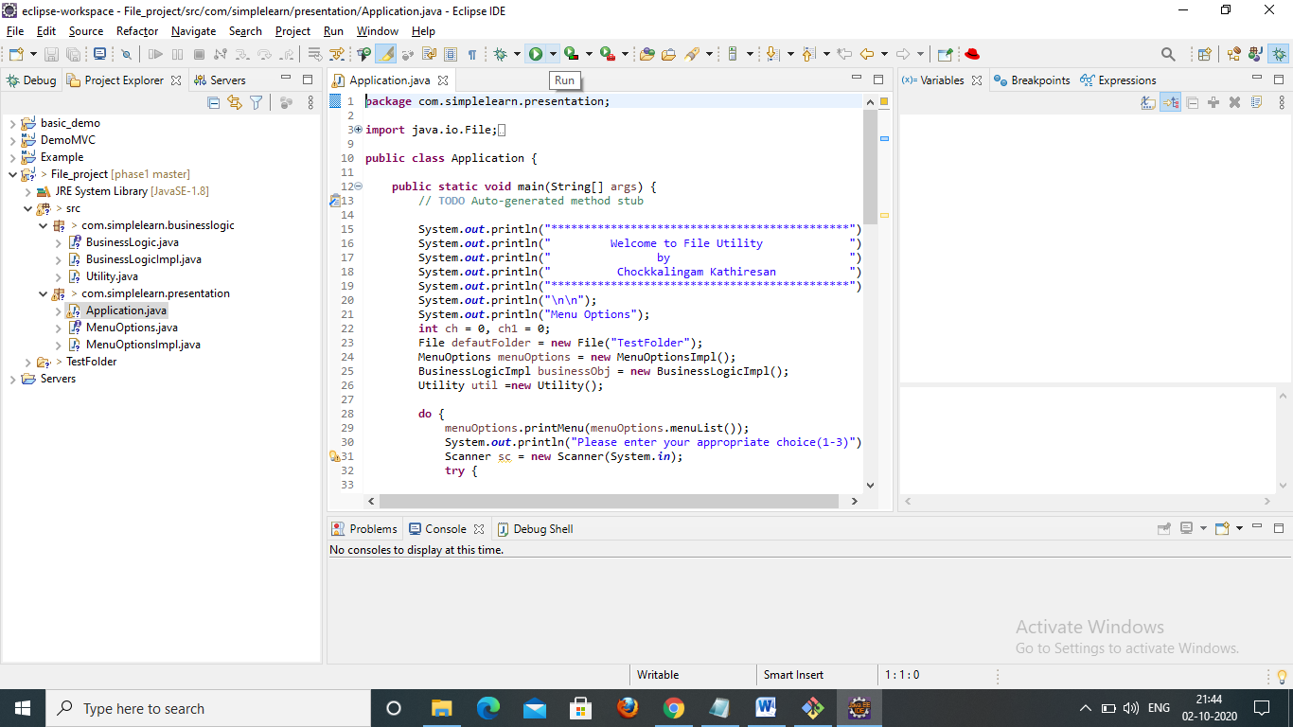
- Click “Run”
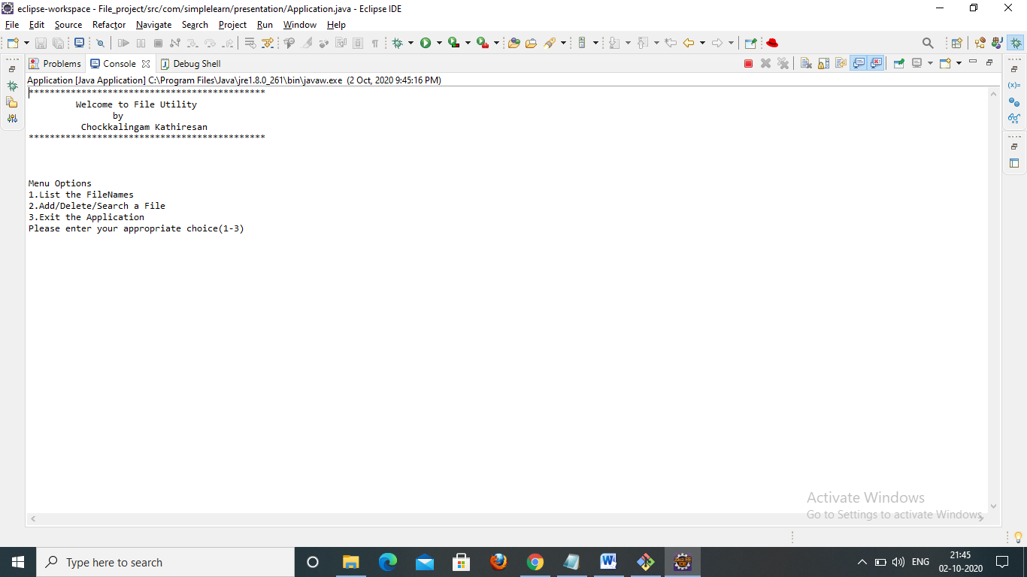
- Click 1 for listing down the file names in the folder
- Click 2 for Add/Delete/Search a file
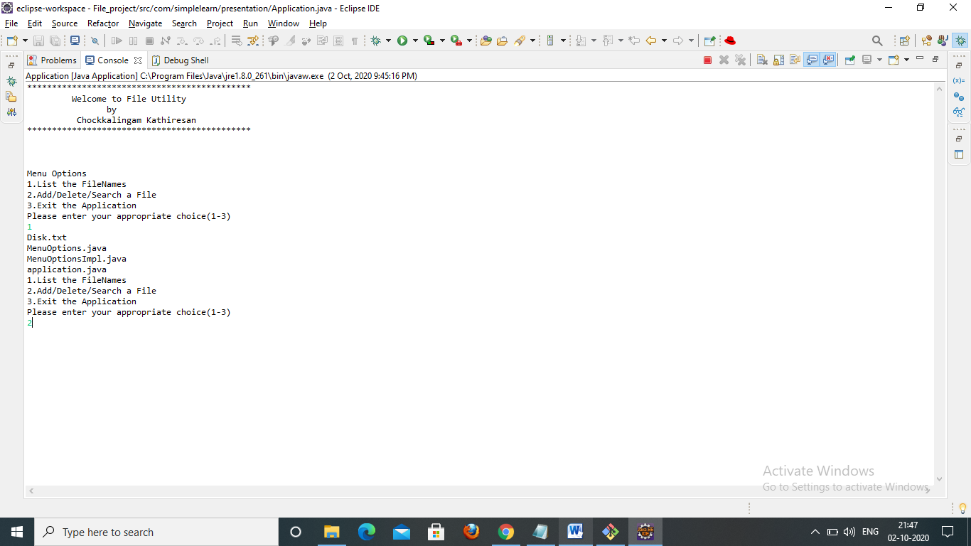
- Click 2
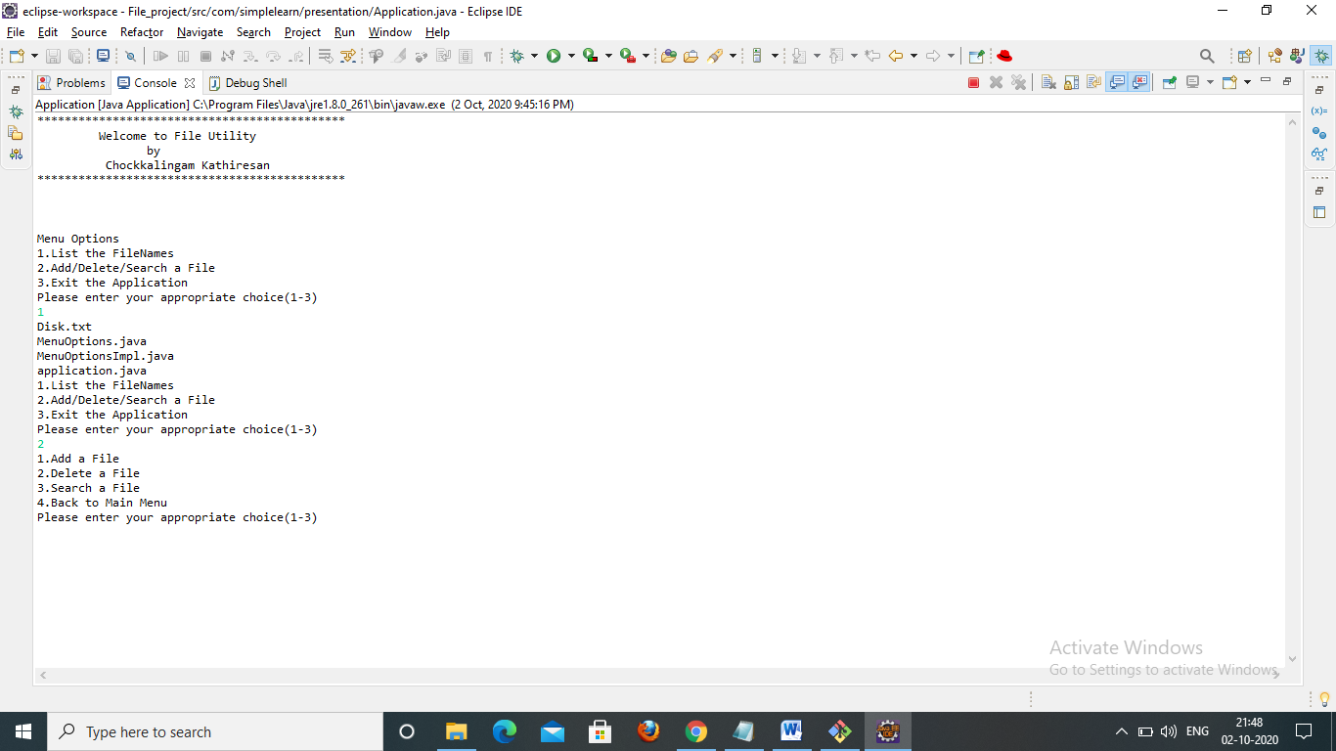
- Click 1 to Add a File and provide the file name with extension and press enter
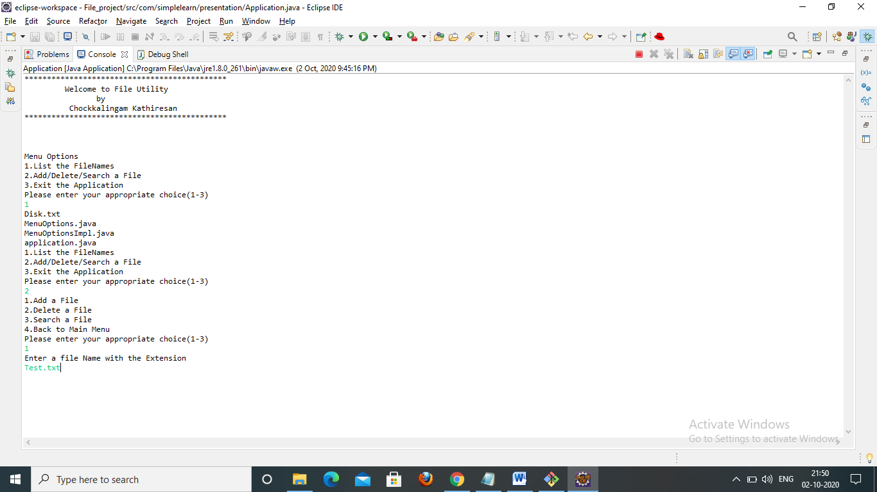
- Click 1 to list the file names
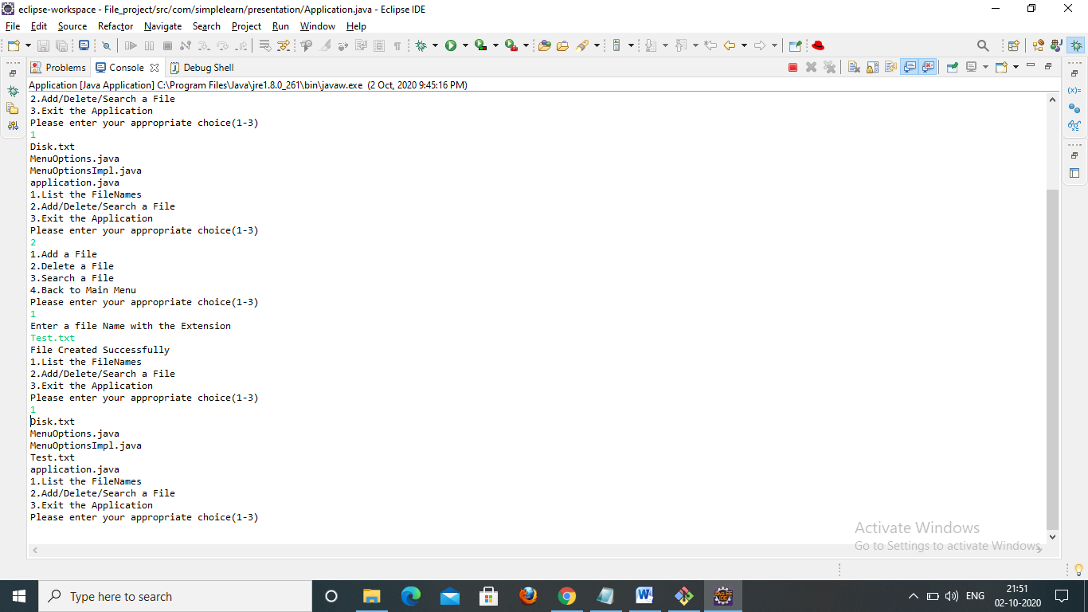
- Click 2 to delete a file name with extension and press enter
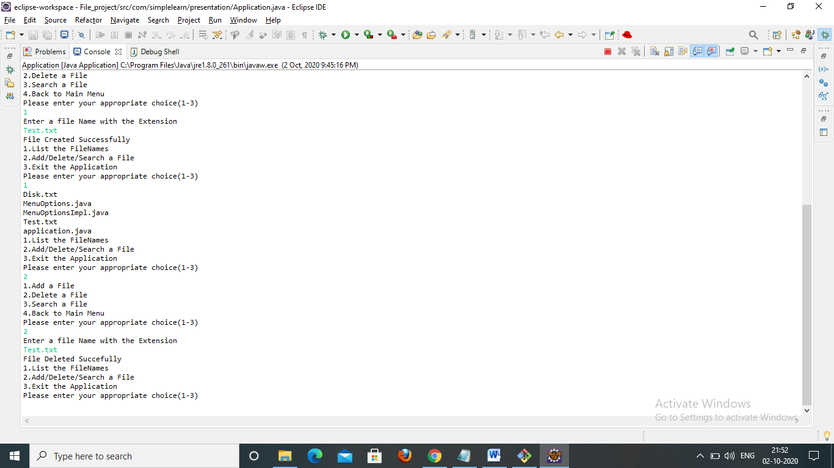
- click 1 to list of file names
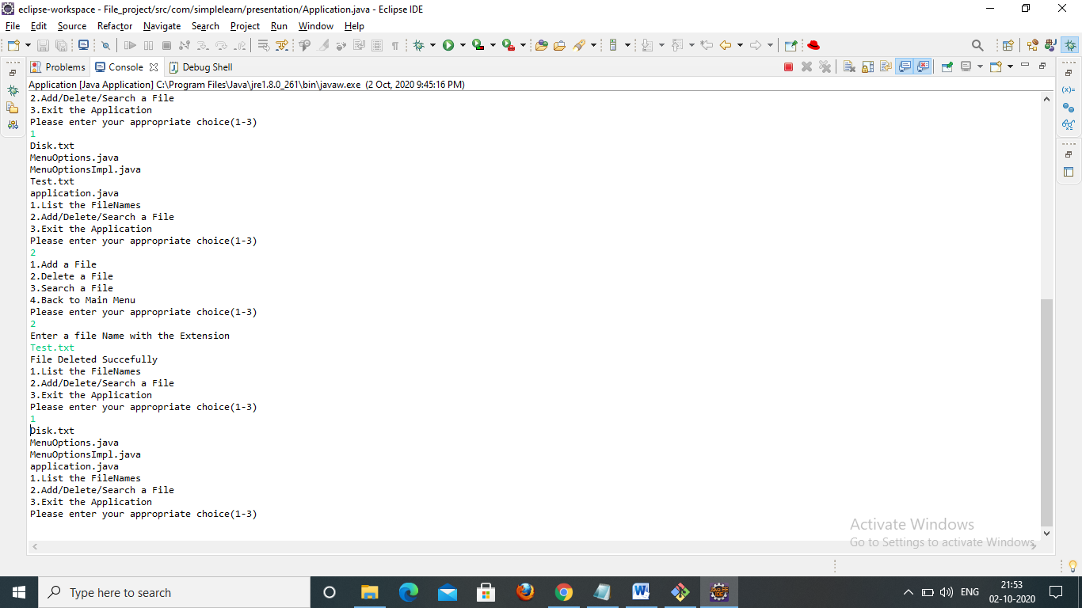
- Click 2 to Add/Delete/Search menu and from the list click 3 to search a file
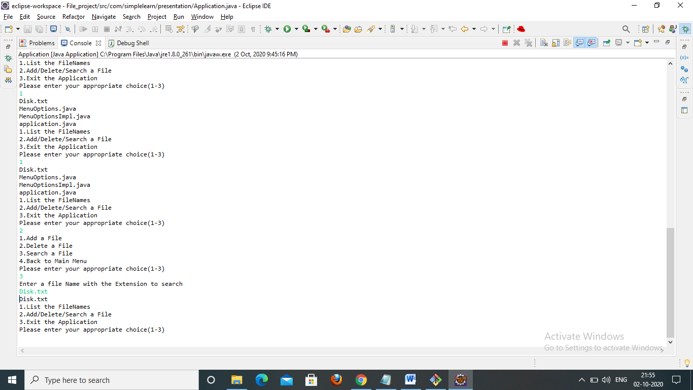
- Click 3 to exit the application
